# Supplementary material for Chapter 2

The following supplementary material is a supplement for chapter 2 showing the methodology used to synthesize and calculate figures provided in the paper.

## Experimental Section

**S-(dimethylarseno)cysteine (10)** 0.445g of Cacodylic acid and 0.9291g of L-Cystine was mixed in distilled water under nitrogen for 16 hours. The precipitate was filtered dried under reduced pressure without heating. 1H NMR (500 MHz, D2O) δ 3.99 – 3.91 (m, 1H), 3.24 – 3.13 (m, 1H), 1.37 (s, 1H), 1.36 (s, 1H).

**Preparation of Me2AsCys Solution.** 0.0115g of Me2AsCys was dissolved in 1 ml of Phosphate buffer at pH 4.2 (10% potassium phosphate buffer was prepared by the dissolution of potassium phosphate into water and subsequent adjustment of pH using NaOH. The solution was deuterated by drying the mixture and re-hydrating it with D2O). This solution was diluted to form a desired concentration of **6.40 mM** by a 1/5 dilution using 200ul of the solution and 800 ul of buffer. To ensure the temperature is changing constantly and as expected, a plot of the solvent chemical shift against temperature. This indicates minimal changes to the pH or random errors in the temperature readings, as the R2 is 0.999. This however does not rule out the possibility of systematic errors to the temperature readings. This could be remedied by using a temperature reference.

# Kinetics determination



NMR data was acquired with a Varian 500 MHz instrument. All NMR acquisitions were made with 16 scans, transform size of 32k and shims were done with a gradient shimming on each measurement. Data was processed using Mnova 6.1.1 FID processing software.

To determine the rate constant of the reaction, the separation of the methyl peaks were used to calculate the rate constant using the following equation:

$$k=\frac{π}{\sqrt{2}}\sqrt{δv^{2}-δ{v_{e}}^{2}}$$

This equation is applicable in this situation as dv and k are much larger than the bandwidth in absence of exchange (0.6 Hz). As it is not possible to lower the sample below 0 degrees due to the freezing point of water, dv was estimated using the lowest experimentally obtained separation of 7.8 Hz (solution of 1mM sample at 10 degrees Celsius).

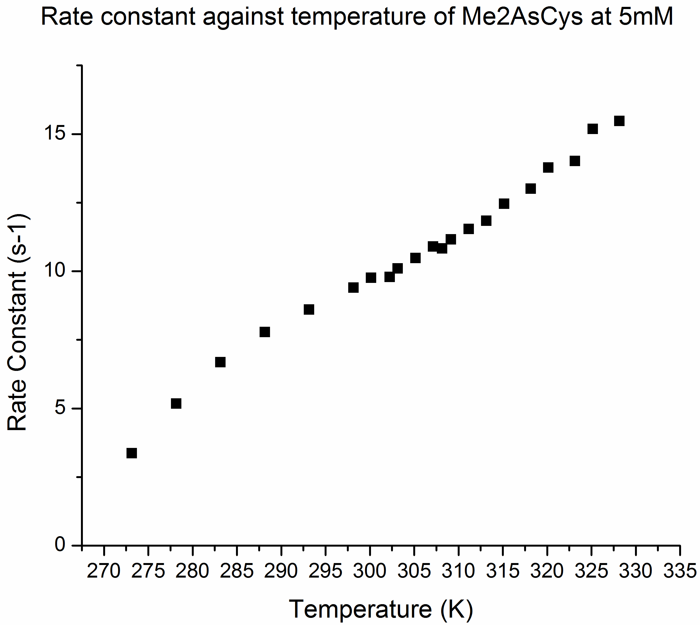

We notice an almost linear build up of the rate constant.

The NMR dynamic exchange was modeled using DNMR3 with Spinworks 3 software. The experimentally determined variables (low temperature limit) of the system at 5’C with a concentration of 1mM was used as the input parameter for the simulation (two spins at 1.3832 and 1.3698 with 0.6 line width). Other parameters include Permutation vector set as 2,1 (mutual exchange of the system), the relaxation time 1 sec (same as acquisition), populations were 0 as this is a case of mutual exchange and maximum iterations = 30. The rate constant RC (1,2) was gradually increased by 1 s-1 until the simulated system exhibited coalescence. It was found that a rate constant of 16 s-1 gave coalescence for the two peaks.